COVID-19 -Public Health Data Visualization Dashboard
A Project Report Submitted in
the partial fulfillment of the requirements for the award of the degree of

BACHELOR OF TECHNOLOGY
In

DEPARTMENT OF COMPUTER SCIENCE AND ENGINEERING
By
K.VISHNU VARDHAN | 2420030515
V.SAI DHANUSH | 2420030162

Under the Esteemed Guidance of

Dr. N. Sunanda

Associate Professor
Department of Computer Science and Engineering

AY-2026-27

Semester : ODD Semester




K L (Deemed to be) University DEPARTMENT OF Computer Science and Engineering (CSE)

Declaration

The Project Report entitled “COVID-19 / Public Health Data Visualization Dashboard” is a record of Bonafide work of K. Vishnu Vardhan – 2420030515 , V. Sai Dhanush – 2420030162 submitted in partial fulfillment for the award of B. Tech in Computer Science and Engineering (CSE)to the K L University. The results embodied in this report have not been copied from any other departments/University/Institute.

K. Vishnu Vardhan – 2420030515
V. Sai Dhanush – 2420030162

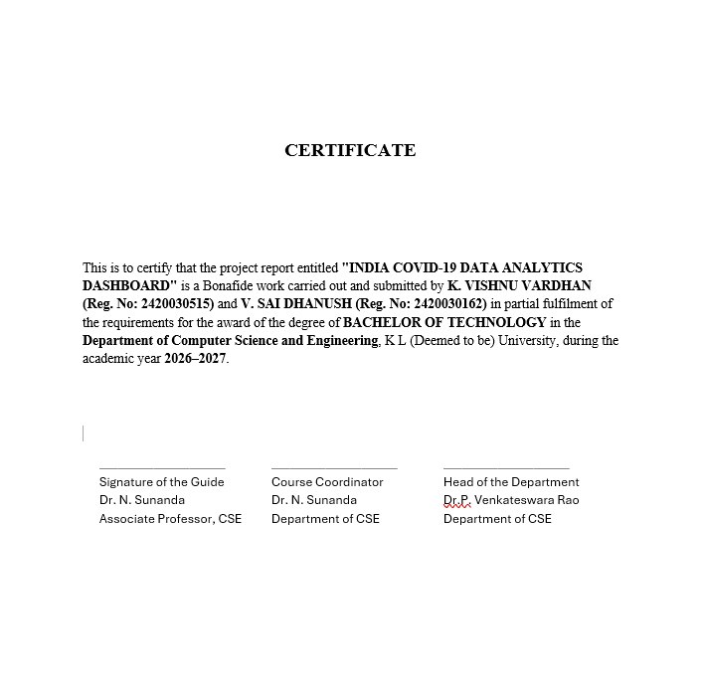

ACKNOWLEDGEMENT

The successful completion of this project would not have been possible without the valuable support, guidance, and encouragement of many individuals. We would like to express our sincere gratitude to everyone who contributed directly or indirectly to the successful completion of our project, “India COVID-19 Data Analytics Dashboard.”
We express our heartfelt thanks to our Course Coordinator and our project guide, Dr. N. Sunanda, from the Department of Computer Science and Engineering, for their continuous support, valuable suggestions, encouragement, and guidance throughout the project.
We extend our sincere gratitude to P. Venkateswara Rao, Head of the Department of Computer Science and Engineering, for providing the necessary facilities and support to complete this project-based laboratory work successfully.
We also thank all the teaching and non-teaching staff members for their assistance and cooperation throughout the project. Finally, we express our gratitude to our parents, friends, and classmates for their constant encouragement, understanding, and support during the completion of this project.

K. Vishnu Vardhan – 2420030515
V. Sai Dhanush – 2420030162

Abstract
The COVID-19 / Public Health Data Visualization Dashboard is a Data Science project developed to analyze COVID-19 related public health data and present the results in a simple and interactive way. The main aim of the project is to convert raw public health data into useful visual insights so that users can easily understand important trends and differences across time periods and regions. First, we will collect a suitable COVID-19 or public health dataset from an open-data source. We will study the structure of the dataset and select the relevant attributes required for analysis. The data will then be cleaned and preprocessed by handling missing values, duplicate records, inconsistent values, and incorrect data formats wherever required. This step will make the dataset suitable for further analysis.
Next, we will perform Exploratory Data Analysis (EDA) to understand the data and identify important patterns and trends. We will use statistical summaries and comparisons to study how the available public health indicators change over different dates, regions, or categories. The purpose of EDA is to understand what is happening in the dataset before presenting the results visually. After the analysis, we will create visualizations using Python libraries such as Matplotlib and Seaborn. Depending on the dataset, the dashboard will include line charts for trends over time, bar charts for comparisons, and distribution or other suitable plots for understanding the data.
These visualizations will make the information easier to read and help users identify increases, decreases, and major differences without examining the raw dataset manually.
Finally, we will combine the processed data and visualizations into an interactive dashboard. The dashboard will provide filters such as region, category, or time period where applicable, allowing users to select the information they want to explore. The final output of the project will therefore be a user-friendly public health dashboard that follows the complete Data Science workflow: data collection, preprocessing, Exploratory Data Analysis, visualization, and interactive presentation. Overall, this project demonstrates how Data Science and data visualization techniques can be used to understand a real-world public health dataset. Instead of only displaying raw numbers, the system presents the data as clear visual insights that can support better understanding and interpretation of COVID-19-related public health trends.

Index
S. No. | Chapters | Topics | Page.no
 |  | Acknowledgement
 |  | Abstract
1 | Introduction | 1.1 Background of the project  1.2 Problem statement  1.3 Scope of the project  1.4 Objective(s)  1.5 Importance of the application  1.6 Target users/audience | 1-10
2 | System Requirements | 2.1 Hardware requirements  2.2 Software requirements  2.3 Development tools and frameworks | 11-20
3 | Technology Stack | 3.1 Front-end (e.g., React.js, Angular, HTML/CSS)  3.2 Back-end (e.g., Node.js, Django, Spring Boot)  3.3 Database (e.g., MongoDB, MySQL, PostgreSQL)  3.4 Version Control (e.g., Git, GitHub)  3.5 APIs or External services (e.g., Firebase, Stripe) | 21-30
4 | System Architecture | 4.1 High-level architecture diagram  4.2 Description of each layer (frontend, backend, database)  4.3 Deployment architecture (e.g., cloud, local, CI/CD pipelines) | 31-35
5 | Design | 5.1 Wireframes or mockups  5.2 ER Diagram / Database schema | 36-42
6 | Implementation | 6.1 Module-wise implementation  6.2 Front-end logic (UI rendering, state management)  6.3 Backend logic (routes, controllers, business logic)  6.4 Database connectivity  6.5 API integration  6.6 Authentication & Authorization | 43-55
7 | Features | 7.1 List of main features  7.2 How each feature works (user perspective + technical description) | 56-60
8 | Testing | 8.1 Postman testing (frontend/backend)  8.2 Integration testing  8.3 Tools used for testing  8.4 Test cases and results | 61-67
9 | Deployment | 9.1 Steps to deploy  9.2 Environment configuration  9.3 Hosting of frontend and backend | 68-73
10 | Challenges & Limitations | 10.1 Issues faced during development  10.2 Solutions applied  10.3 Current limitations or known bugs | 74-80
11 | Future Enhancements | 11.1 Planned features  11.2 Possible integrations or optimizations | 81-88
12 | Conclusion | 12.1 Summary of the project  12.2 What was achieved  12.3 Skills learned during development | 89-100
13 | References | - Books, tutorials, APIs, documentation sites used
14 | Appendices | - Screenshots of the app  - Sample code snippets  - Installation/setup instructions  - User manual or guide

CHAPTER 1
Introduction

  - Motivation
The motivation behind the COVID-19 / Public Health Data Visualization Dashboard is to simplify the analysis and interpretation of COVID-19-related public-health data through data science techniques and interactive visualizations. By combining data preprocessing, Exploratory Data Analysis (EDA), and graphical representation, the project aims to transform raw data into meaningful and understandable visual insights.

  - Objective
The main objective of the COVID-19 / Public Health Data Visualization Dashboard is to develop an interactive dashboard that transforms raw COVID-19 and public-health data into clear, meaningful, and easy-to-understand visual insights.
1.3 Background of the Project
Data Science provides methods for collecting, processing, analyzing, and interpreting large datasets. In public health, these methods can be used to study patterns in reported cases, deaths, recoveries, testing statistics, and other health-related indicators. Analyzing such information across different dates and geographical regions can help users understand changes and differences within the available data.
Data visualization is an important part of this process because it presents information through graphical representations instead of relying entirely on numerical tables. Line charts can be used to examine changes over time, while bar charts can help compare values across states or regions. Statistical summaries can provide an overview of the available data and support further analysis.
The proposed project, COVID-19 / Public Health Data Visualization Dashboard, follows a data science workflow consisting of data collection, data inspection, preprocessing, Exploratory Data Analysis, visualization, and interactive presentation.
1.4 Problem Statement
COVID-19 and public-health datasets contain large amounts of information across different dates, geographical regions, and health indicators. Although these datasets can provide useful information, raw numerical data is often difficult to understand and compare manually.
Large and complex datasets make it challenging to identify important patterns and trends. Missing values, duplicate records, inconsistent information, and incorrectly formatted data may affect the quality and reliability of analysis. Furthermore, comparing public-health information across states, districts, and different time periods can require considerable effort when users depend only on raw data files.
1.5 Scope of the Project
The project uses CSV datasets as its identified data inputs. The proposed technology stack includes Python, Pandas, and NumPy for data processing; a Python API for backend communication; and React.js, JavaScript, and CSS for the frontend.
The dashboard is intended to support the exploration and interpretation of the available data. Its accuracy depends on the quality of the source datasets, appropriate preprocessing, and correct calculations. The project does not replace official public-health reporting or provide clinical advice.

1.6 Importance of the Project
The COVID-19 / Public Health Data Visualization Dashboard is important because it provides a structured way to explore public-health information without requiring users to examine multiple raw data files manually.
The use of data preprocessing and Exploratory Data Analysis helps identify data-quality issues and understand the characteristics of the available information. Visual representations can make changes over time and differences between regions easier to recognize.
1.7 Target Users
The intended users of the COVID-19 / Public Health Data Visualization Dashboard include:
- Students: To understand the practical application of Data Science, data preprocessing, EDA, and visualization.
- Data Science learners: To explore public-health datasets and practice analyzing patterns across regions and time periods.
- Researchers: To examine available COVID-19 indicators through descriptive statistics and graphical representations.
- Public-health data users: To explore historical public-health information and compare available indicators across geographical regions.
- Project evaluators and academic users: To understand how data processing and interactive visualization can be integrated into a data science application.

CHAPTER 2
Software Requirement

2.1 Problem Statement
The COVID-19 pandemic highlighted the importance of collecting, analyzing, and presenting public health data in an understandable format. Large amounts of data related to confirmed cases, testing, and regional disease trends are generated and stored in different datasets. However, analyzing this information manually can be time-consuming and makes it difficult to identify trends, compare regions, and understand changes over time.
The COVID-19 / Public Health Data Visualization Dashboard aims to address these challenges by providing a centralized platform for processing, analyzing, and visualizing public health data. The system uses data processing techniques and interactive charts to present meaningful information about COVID-19 cases, testing statistics, and regional trends. Users can explore the available data through visual representations, making it easier to understand patterns and compare statistics across different regions and time periods.
  - Technologies used

1. HTML5
HyperText Markup Language (HTML) is the standard markup language used to structure content displayed in web browsers. It provides the basic structure for web pages, including headings, paragraphs, sections, and other interface elements. In this project, HTML5 supports the structure of the COVID-19 dashboard interface through the React.js application.

General Syntax of HTML:
<!DOCTYPE html>
<html>
<head>
<title>COVID-19 Dashboard</title>
</head>
<body>
<h1>COVID-19 Data Visualization Dashboard</h1>
<p>Explore COVID-19 statistics and trends.</p>
</body>
</html>
2. CSS3
Cascading Style Sheets (CSS) is a stylesheet language used to control the presentation and layout of web pages. It defines colors, fonts, spacing, backgrounds, borders, and responsive layouts.
In this project, CSS is used to design the dashboard interface, style summary cards, organize charts, and improve the overall user experience. Responsive styling helps the dashboard adapt to different screen sizes.

Types of CSS:
2.1 Inline CSS: Inline CSS applies styling directly to an individual HTML element. It is suitable for small, specific styling changes but can make code difficult to maintain when used extensively.
2.2 Internal CSS: Internal CSS is written inside the <style> element within the HTML document's <head> section. It can be used to style elements on a particular page.
2.3 External CSS: External CSS is written in a separate .css file and linked to the application. It helps maintain consistent styling and makes the code easier to manage.
3. JavaScript
JavaScript is a programming language used to implement dynamic and interactive functionality in web applications. It allows web pages to respond to user actions and update displayed information.
In this project, JavaScript is used to handle user interactions, manage dashboard components, apply selected filters, and display data received from the backend. It works with React.js to provide an interactive dashboard experience.
4. React.js
React.js is a JavaScript library used to build user interfaces through reusable components. It supports the development of dynamic web applications by updating the interface when the underlying data or application state changes.
In the COVID-19 dashboard, React.js is used to create components such as summary cards, filter controls, charts, and data display sections. Its component-based structure helps organize the frontend code and simplifies maintenance.
5. Python
Python is a high-level programming language widely used for data analysis, scientific computing, and backend development. Its readable syntax and extensive library ecosystem make it suitable for processing large datasets.
In this project, Python is used to load COVID-19 datasets, clean and organize the data, perform calculations, and prepare information for visualization. A Python-based API can also provide processed data to the React.js frontend, depending on the implemented backend.
6. Pandas
Pandas is a Python library used for data manipulation and analysis. It provides data structures such as DataFrames that make it easier to work with structured datasets.
In this project, Pandas is used to read CSV files, handle missing values, filter records, organize dates and regional information, and calculate relevant statistics from COVID-19 datasets.
7. NumPy
NumPy is a Python library used for numerical computing. It provides efficient operations on arrays and supports mathematical calculations.
In this project, NumPy can be used for numerical operations and statistical calculations required during data processing and analysis.
8. Matplotlib
Matplotlib is a Python library used to create charts and graphs from numerical and structured data. It supports different visualization types, including line charts, bar charts, and histograms.
In this project, Matplotlib can be used during data exploration and analysis to visualize COVID-19 trends, compare statistics, and examine changes in the available datasets.
9. Seaborn
Seaborn is a Python data visualization library built on Matplotlib. It provides functions for creating statistical charts with clear visual presentation.
In this project, Seaborn can be used during exploratory data analysis to study statistical distributions, compare regional data, and identify patterns in COVID-19 datasets.

  - Software Used

2.3.1 Visual Studio Code (Text Editor)
Visual Studio Code (VS Code) is a source-code editor used for software development. It supports multiple programming languages and provides features such as syntax highlighting, debugging, extensions, and an integrated terminal.
In this project, Visual Studio Code is used to develop and manage the React.js frontend, Python backend, CSS stylesheets, and other application files. It provides a convenient environment for writing, testing, and debugging the project code.

2.3.2 Web Browser
A modern web browser, such as Google Chrome or Microsoft Edge, is used to run and test the dashboard application. The browser displays the frontend interface and allows users to interact with available filters, charts, and dashboard components.

2.3.3 Python Environment
Python and its package manager, pip, are used to execute Python programs and install the required libraries, such as Pandas, NumPy, Matplotlib, and Seaborn.
The Python environment supports dataset preprocessing, exploratory data analysis, and backend functionality where applicable.

2.3.4 Node.js and npm
Node.js is a JavaScript runtime used to execute JavaScript outside the browser. npm (Node Package Manager) is used to install and manage the packages required by the frontend application.
In this project, Node.js and npm support the development and execution of the React.js application and help manage its dependencies.

2.3.5 CSV Dataset Files
Comma-Separated Values (CSV) files are used to store structured COVID-19 data. The project datasets include files such as complete.csv, state_level_daily.csv, state_level_latest.csv, district_level_latest.csv, nation_level_daily.csv, tests_day_wise.csv, tests_state_wise.csv, and patients_data.csv.
These files contain information related to COVID-19 cases, regional statistics, testing, and patient records. The data is processed to generate useful visualizations and insights.
CHAPTER 3
Software Design

3.1 DFD
A data-flow diagram (DFD) is a way of representing a flow of a data of a process or a system (usually an information system). The DFD also provides information about the outputs and inputs of each entity and the process itself. A data-flow diagram has no control flow, there are no decision rules and no loops. Specific operations based on the data can be represented by a flowchart.
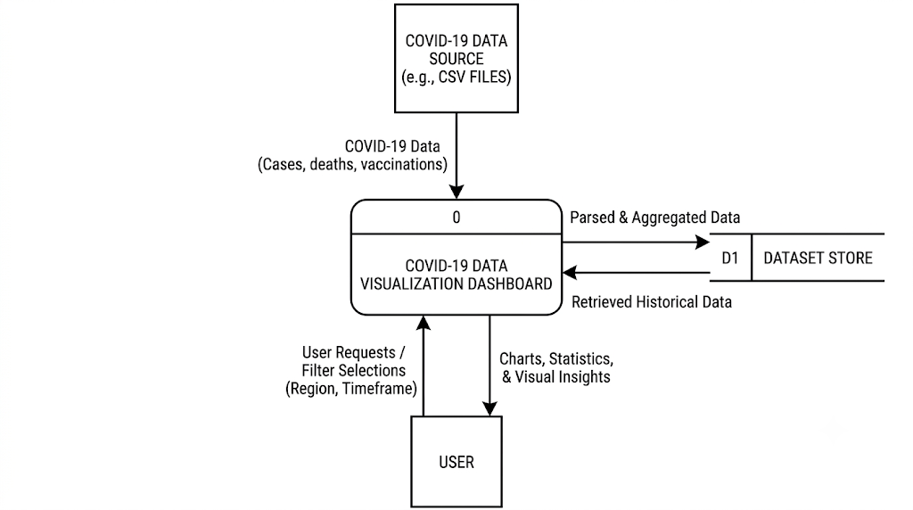 Fig No. 3.1 DFD LEVEL-0
3.2-System Architure: 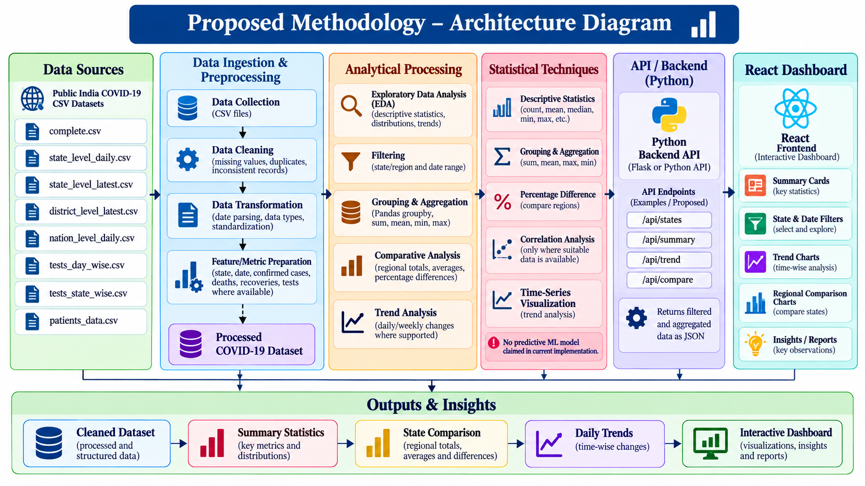

CHAPTER 4
IMPLEMENTATION AND USER INTERFACE
4.1 Web Page Details
The India COVID-19 Data Analytics Dashboard consists of the following pages and modules:
- Login and Registration Page
- Overview Dashboard
- National Analytics
- State Analytics
- District Analytics
- Testing Analytics
- Data Explorer
- Insights and Reports
- Methodology
- Profile and Settings
4.2 Detailed Description of Pages
1. Login and Registration Page
The Login and Registration page allows users to access the dashboard through the authentication interface. New users can register, while existing users can log in to access the available dashboard features.
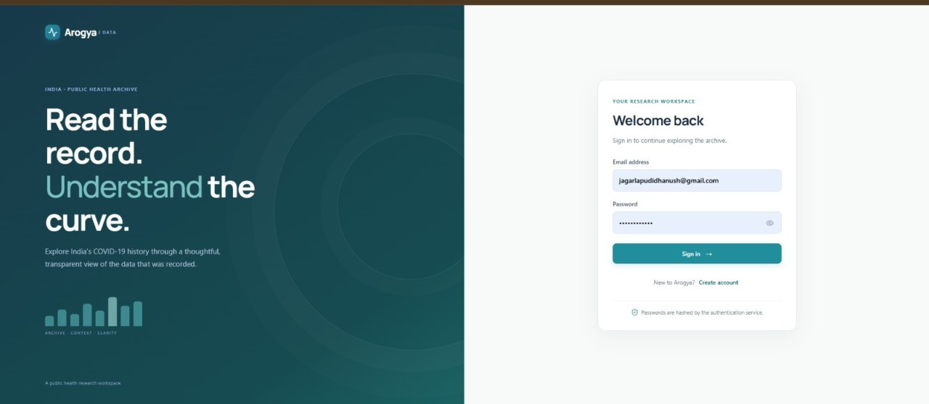
Fig. No. 4.1: Login and Registration Page
2. Overview Dashboard
The Overview Dashboard provides a summary of COVID-19 statistics through key indicators, charts, and visual representations. It helps users understand the overall status of the available COVID-19 data, including confirmed cases, recoveries, deaths, and other relevant statistics
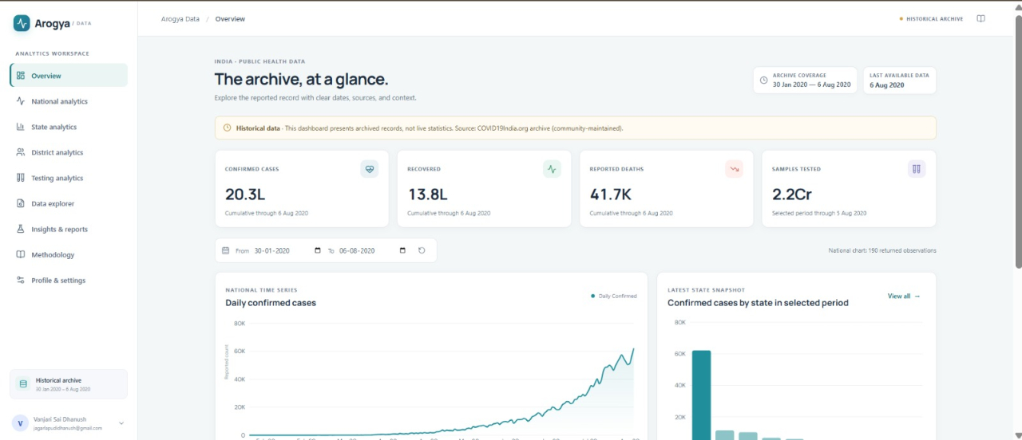
Fig. No. 4.2: Overview Dashboard
3. National Analytics Page
The National Analytics page presents COVID-19 statistics at the national level. Users can explore date-wise trends and examine changes in confirmed cases, recoveries, and deaths over time through graphical visualizations.
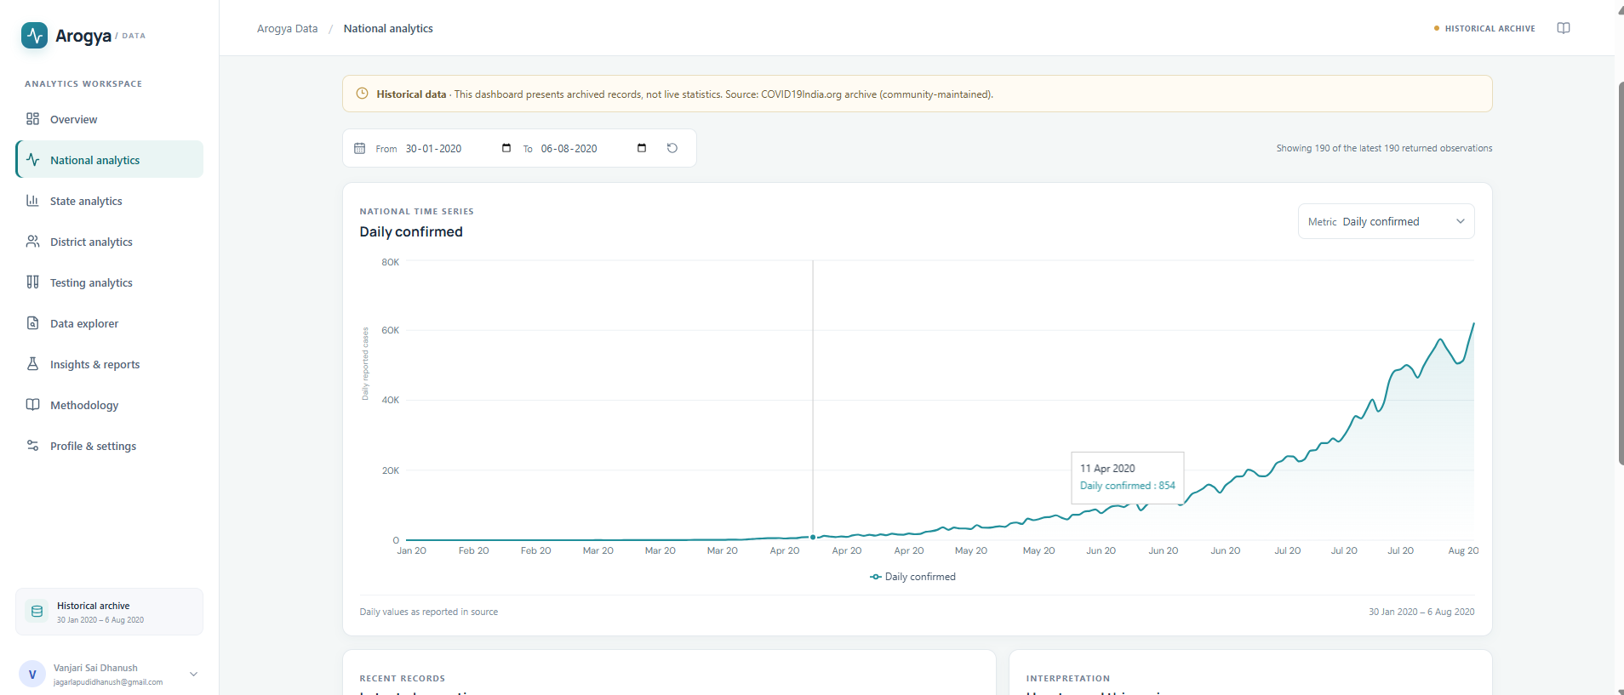
Fig. No. 4.3: National Analytics Page

4. State Analytics Page
The State Analytics page enables users to examine COVID-19 statistics for different states and union territories in India. It supports regional comparison and helps users identify differences in reported cases, recoveries, and deaths among states.
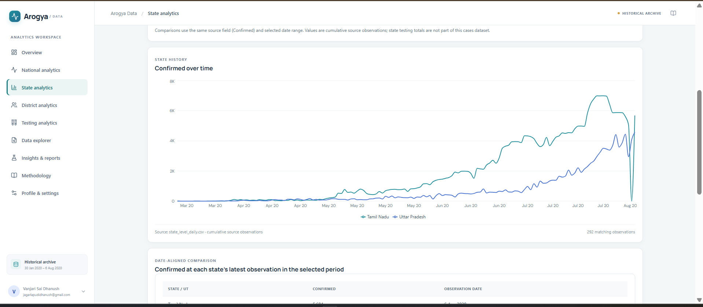
Fig. No. 4.4: State Analytics Page
5. District Analytics Page
The District Analytics page provides district-level COVID-19 information wherever the available dataset supports it. Users can explore reported cases, recoveries, deaths, and other available district-level statistics to understand regional variations.
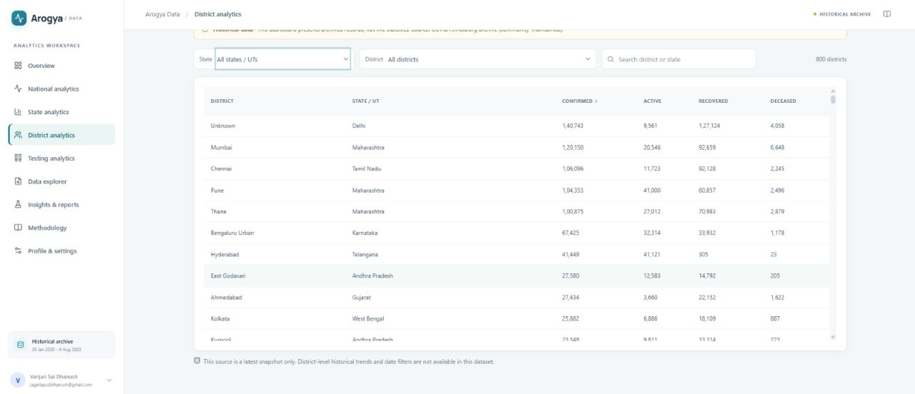
Fig. No. 4.5: District Analytics Page

6. Testing Analytics Page
The Testing Analytics page presents available COVID-19 testing information, including testing counts and related statistics. It helps users examine testing patterns and understand the relationship between testing data and reported cases.
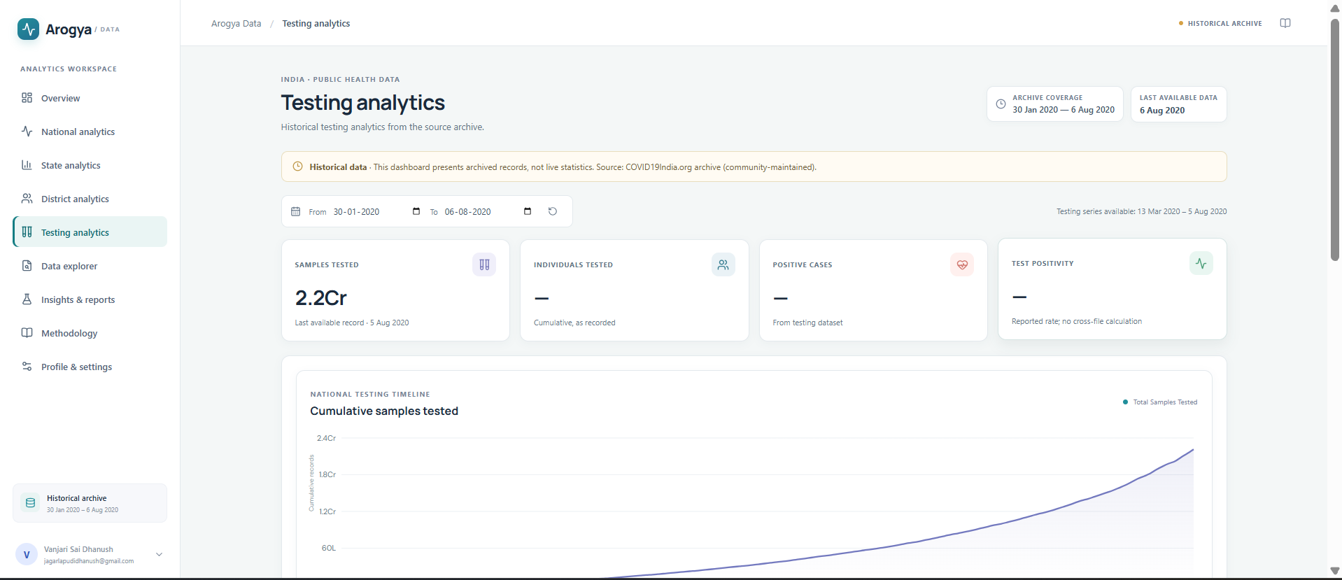
Fig. No. 4.6: Testing Analytics Page
7. Data Explorer Page
The Data Explorer provides a structured view of the COVID-19 datasets. Users can browse records, inspect data fields, and use available filtering and pagination features to find relevant information. This module improves accessibility to the underlying data.
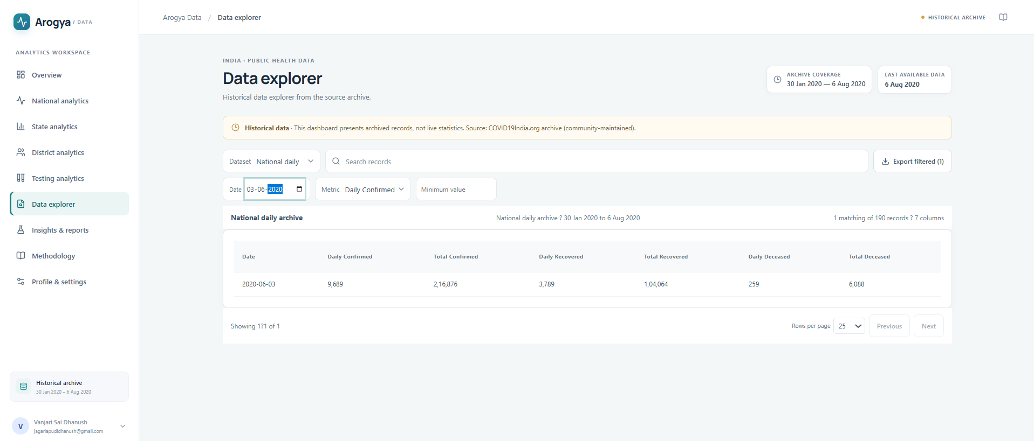
Fig. No. 4.7: Data Explorer Page

8. Insights and Reports Page
The Insights and Reports page presents summaries and observations derived from the available COVID-19 records. It helps users interpret trends and compare statistics across selected dates and regions. The insights are based on the available data and are intended for descriptive analysis.
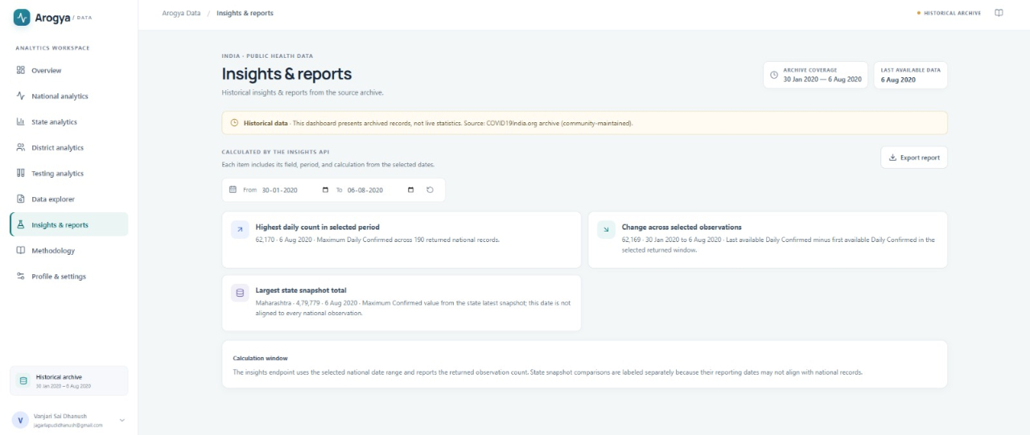
Fig. No. 4.8: Insights and Reports Page
9. Methodology Page
The Methodology page explains the data sources, preprocessing approach, analytical methods, and limitations of the dashboard. It provides information about how the COVID-19 datasets are organized and used for visualization and analysis.
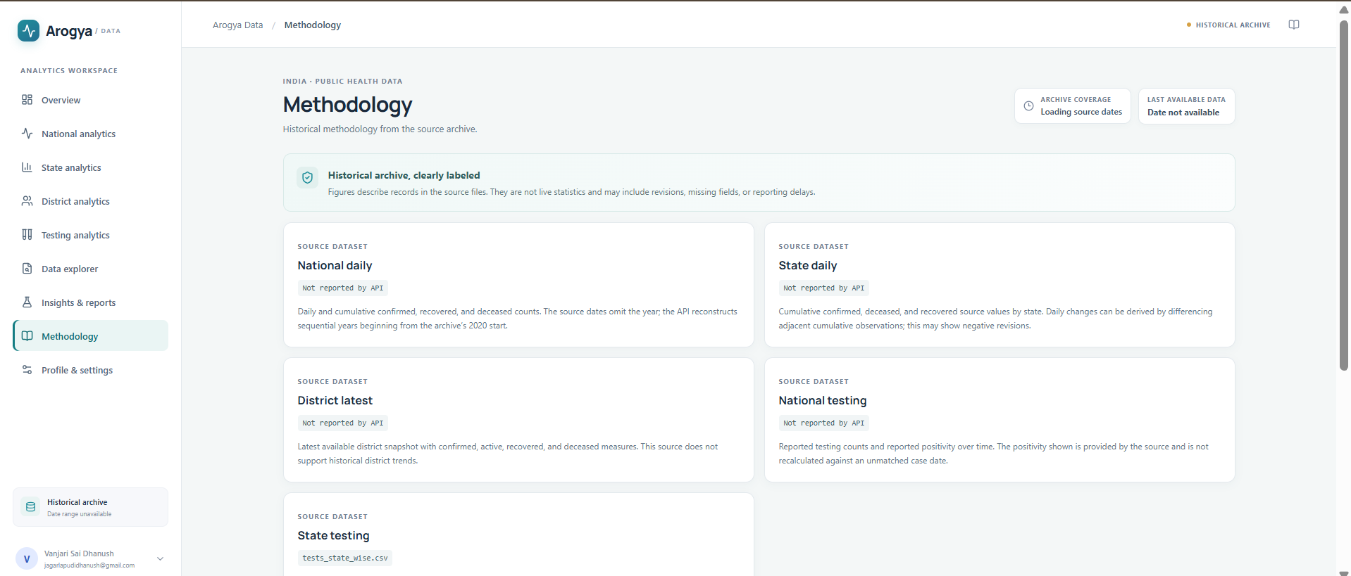
Fig. No. 4.9: Methodology Page

10. Profile and Settings Page
The Profile and Settings page provides the user interface for available account preferences and settings. It allows authenticated users to manage supported preferences within the application.
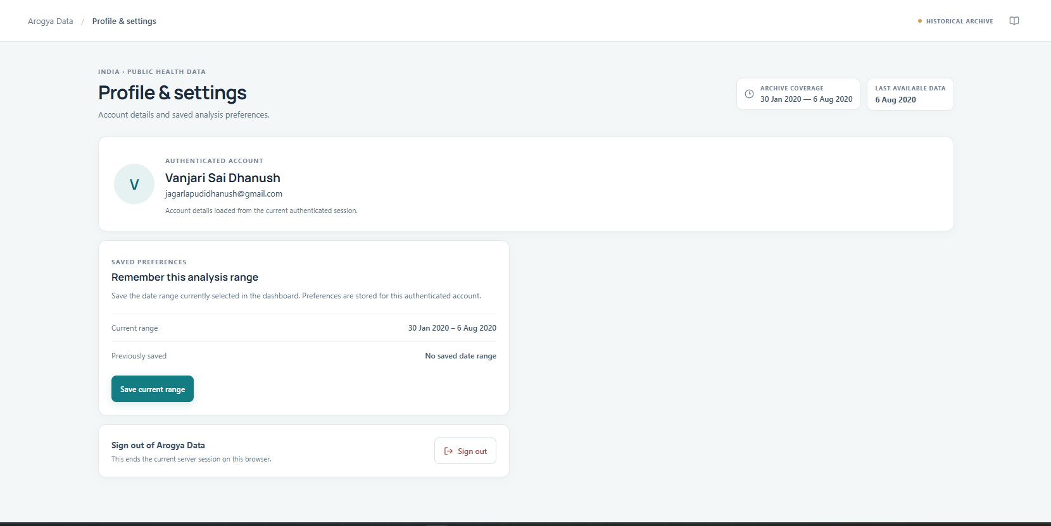
Fig. No. 4.10: Profile and Settings Page
4.3 Implementation Overview
The dashboard is implemented using React.js for the frontend and Python Flask for the backend API. Pandas and NumPy support data processing and analysis, while SQLite is used for database-related functionality. The frontend communicates with the backend through HTTP requests and receives responses in JSON format.
The system combines the available COVID-19 datasets with interactive visualizations, allowing users to explore national, state, district, and testing statistics through a unified web interface.

CHAPTER 5

Conclusion and Future Aspects
We have successfully developed the India COVID-19 Data Analytics Dashboard to analyze and visualize COVID-19 data across India. The project uses React.js for the frontend, Python Flask for the backend, Pandas and NumPy for data processing, and SQLite for database management. The dashboard provides interactive visualizations and data analysis related to national, state, district, and testing statistics. Users can explore trends, compare data, and gain insights into the spread of COVID-19 through charts, tables, and filters. The project demonstrates how data analytics and visualization can make large datasets easier to understand. Overall, the dashboard provides a useful platform for students, researchers, and other users to explore historical COVID-19 data and understand its trends.

5.1 Future Aspects
- Real-Time Data Updates: Integrate reliable and official data sources to keep the dashboard updated with the latest available information.
- Advanced Data Visualization: Add more interactive charts, graphs, maps, and comparison tools to improve data exploration.
- Predictive Analytics: Incorporate machine learning models to forecast possible trends in infections, recoveries, and testing, with appropriate validation.
- Advanced Search and Filtering: Provide more search options to help users find specific states, districts, dates, and statistical information quickly.
- Mobile-Friendly Interface: Improve the responsive design so users can access the dashboard easily on smartphones and tablets.
- Downloadable Reports: Allow users to export filtered data, charts, and analytical summaries in PDF, CSV, or Excel formats.
- Deployment and Scalability: Deploy the application on a cloud platform and optimize it to support more users and larger datasets.
CHAPTER 6
Bibliography

- Salehi, M., Arashi, M., Bekker, A., Ferreira, J., Chen, D.-G., Esmaeili, F., and Frances, M. (2021). “A Synergetic R-Shiny Portal for Modeling and Tracking of COVID-19 Data.” Frontiers in Public Health, 8, 623624. https://doi.org/10.3389/fpubh.2020.623624
- Clarkson, M. D. (2023). “Web-Based COVID-19 Dashboards and Trackers in the United States: Survey Study.” JMIR Human Factors, 10, e43819. https://doi.org/10.2196/43819
- Schulze, A., Brand, F., Geppert, J., and Böl, G.-F. (2023). “Digital Dashboards Visualizing Public Health Data: A Systematic Review.” Frontiers in Public Health, 11, 999958. https://doi.org/10.3389/fpubh.2023.999958
- Dixon, B. E., Grannis, S. J., McAndrews, C., Broyles, A. A., Mikels-Carrasco, W., Wiensch, A., Williams, J. L., Tachinardi, U., and Embi, P. J. (2021). “Leveraging Data Visualization and a Statewide Health Information Exchange to Support COVID-19 Surveillance and Response: Application of Public Health Informatics.” Journal of the American Medical Informatics Association, 28(7), 1363–1373. https://doi.org/10.1093/jamia/ocab004

CHAPTER 7

Appendices

7.1 CSS
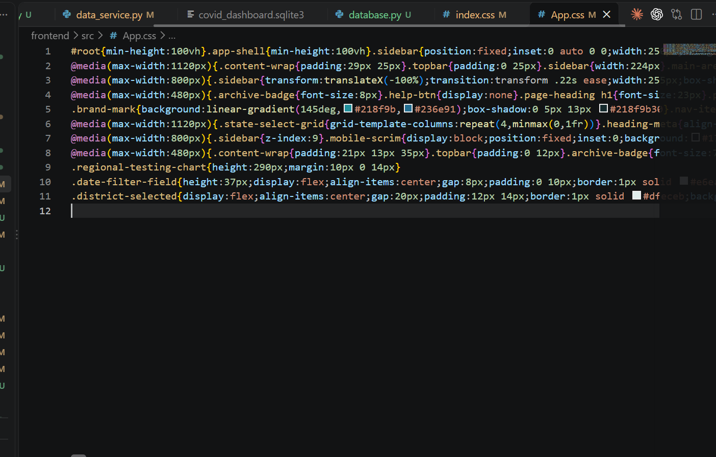
7.2 HEAD
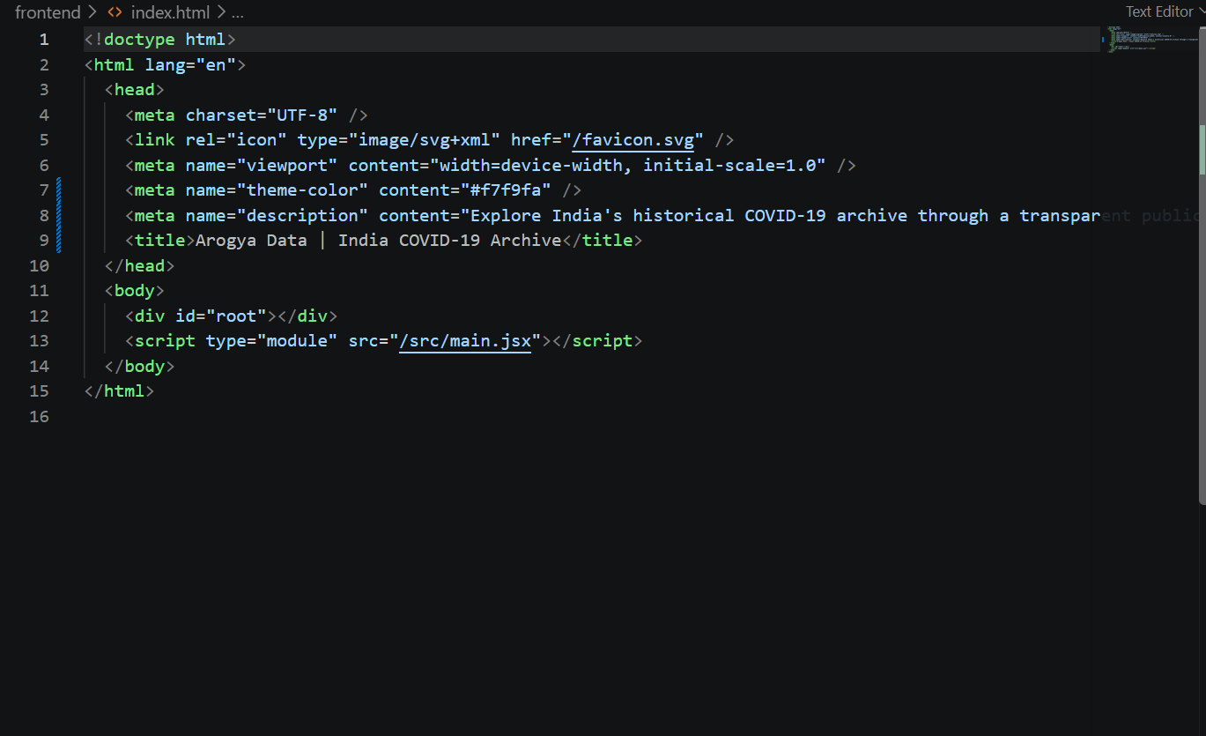

7.3 React dashboard / chart
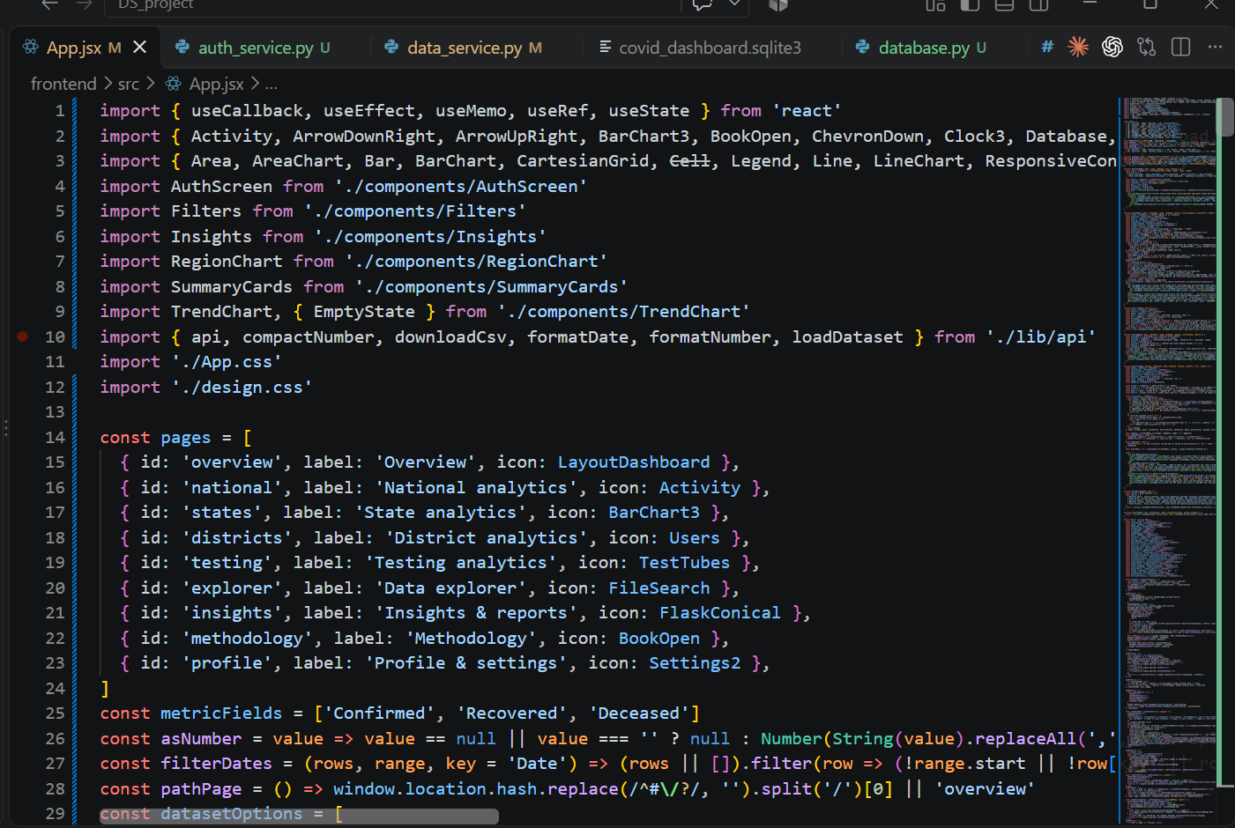
7.4 Data preprocessing using Pandas
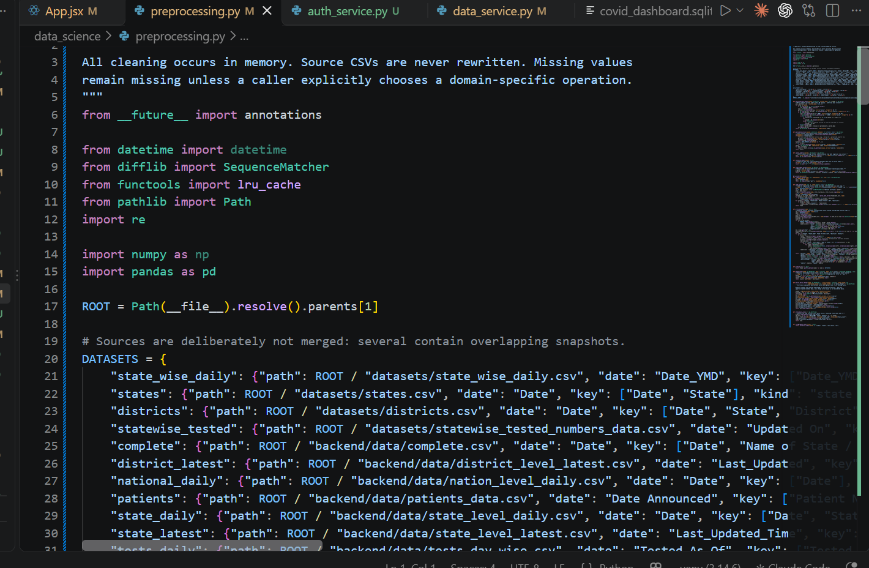

7.5 Flask API


